**WALNUT RIDGE HIGH SCHOOL STUDENT HANDBOOK**



**4841 E. Livingston Ave**

**Columbus, Ohio 43227**

**Lunch**

Beginning in the 23/24 SY, WRHS will have one lunch period which is scheduled for 5th period. During lunch, the entire building will shut down except for the following areas…

* The Cafeteria
* The Cafeteria Patio (area bounded by railing) and the grass immediately adjacent to the Cafeteria Patio for students who wish to engage in sports other than volleyball or basketball
* The hallway outside the Cafeteria where students may sit on the benches
* The Gym where students can engage in volleyball and basketball
* (Homan Room) for adult supervised

*No other locations in the building will be accessible to students* ***except*** *for students who need to be seen by the Nurse at lunchtime. After seeing the Nurse, students are to return to the spaces listed above.*

*Procedures*

* At the beginning of 5th Period Lunch, all students will report to the spaces listed above.
* All students will remain in the above areas for the duration of 5th period.
* No students will be permitted to go to any other destination during lunch.
* (Homan Room) can be scheduled with Mr. Murphy for any adult-directed lunch-time activities.
* Students are not permitted to leave the campus during 5th period.
* Students are not permitted to have food delivered to WRHS.
* Students may take food to the patio, disposing of the trash in the outside containers, food will not be permitted anywhere else in the building/on the grounds.
* Students will determine when they wish to go to the cafeteria to eat or any of the spaces listed above. Staff in the Cafeteria and the Gym (only) will indicate when half of the period has elapsed.
* No food will be served after 11:40 AM.
* Duty staff will ensure that students do not leave the designated areas, encourage appropriate behavior, and develop relationships with kids. Safety Team members will be available in the Cafeteria, on the Cafeteria Patio, and in the Gym to address emergencies or safety concerns.
* ISS students will eat lunch from 10:12 - 10:59 AM in the Cafeteria, no other space will be available.

Attendance (Hull)

1. Students need to arrive to school on-time and stay until the end of the day in order to be successful
2. Students are required to be in all their scheduled classes
3. Students must have an E-Hall pass for valid reasons to leave class
4. No E-Hall passes will be given the first or last ten minutes of class
5. HB 410 - It is important for our students to be in school every day. A child who is not in school misses out on parts of his/her education. The state of Ohio defines "chronic absenteeism" as missing 10% or more of the school year. These days are counted as absent, even when the student has an excuse for the absence. Because we have period-by period attendance, absences are calculated by the total number of hours the students miss. We encourage all students to be in class on time, every day, ready to learn.

Gym Guidelines

1. Only students with Physical Education as a scheduled class will be allowed to be in the gym
2. Students are required to stay in the gym for the entire duration of class (No TikToks in the hallway)
3. Individual students and/or classes may not be sent to the gym

Matriculation

[Matriculation Plan](https://docs.google.com/document/d/1se0UPGPIt9ZKQlkuPBJxQB1PmiJQ6ep0wdWsMkciwyU/edit?usp=sharing)

EMERGENCY PROCEDURES

The safety and security of students requires that all students exercise disciplined and attentive behavior during fire, tornado and emergency drills. Student awareness and orderliness is required to facilitate emergency situations. Fire, tornado, emergency evacuation and emergency lockdown drills are held several times during the school year. The school's emergency address system will be used to instruct you during these times.

During a Fire Drill or Emergency Evacuation, students are expected to:

● Remain with the class and instructor.

● Walk quietly from the building area and listen for instructions.

● Respond to school personnel directions without hesitation.

● Leave the building via the exit designated by the instructor.

● Report to the class assembly point to have attendance taken.

● Remain alert for emergency vehicles.

● Return to the building only when instructed.

During a Tornado Drill, students are expected to:

● Remain with the class and instructor.

● Walk quietly within the building halls to the designated area and listen for instructions.

● Students are to face the wall in a seated position (tornado readiness).

● Respond to school personnel directions without hesitation.

● Remain alert for emergency vehicles.

● Return to the classroom only when instructed.

During an Emergency Lockdown, students are expected to:

● Remain in their classroom with the class and instructor.

● If caught outside the classroom or office, go to the nearest room and remain there.

● Respond to school personnel directions without hesitation.

● Students are to position themselves out of view of all doors and windows and remain absolutely silent.

● Remain in their secure location and position until released by the police, admin or safety and security unlocking doors.

Vision (Team)

Athletics (Shep)

**Purpose**:

The interscholastic Walnut Ridge Athletic Program seeks to provide each student-athlete the opportunity to develop and gain the necessary life skills that will prepare them for the future.

The Walnut Ridge Athletic Program will continue to promote the mission of Columbus City Schools, which is that each student is highly educated, prepared for leadership and service, and empowered for success as a citizen in a global community.

**Vision**:

**To be a model program excelling in academics and athletics.**

**Sports Offered:**

**Fall Sports**: Football, Volleyball, Soccer, Cross Country, Girls Tennis, Cheerleading, Drill

**Winter Sports:** Basketball, Bowling, Wrestling

**Spring Sports**: Baseball, Softball, Track and Field, Boys Tennis

**Eligibility**

* Each Student-Athlete must earn 5 passing grades and a 2.0 in order to be eligible to participate in Athletics.
* Each student must have a valid physical on file in order to participate.

**Game Admission**:

* Tickets can be purchased at locallevelevents.com
* Admission is $5

**After School policy**

* Each student-athlete will be under the supervision of their particular coach after school at 2:45pm. Student-Athletes will remain with their coach until the end of practice. After practice is complete, he/she must exit the building.
* No one is permitted to be in the building unsupervised.

Testing (AG)

**Counseling**

[WRHS Handbook - Support Service](https://docs.google.com/document/d/1iu3huRh1JOHfXzmLvhpqCqKc-iHH0_3PE_Rh6I0RX2M/edit?usp=sharing)

**Grading Policy**

Grades are the way schools document student progress as they earn a diploma. Accordingly, it is important that all members of the learning community understand the expectations around how grades are calculated and entered into the student information system…

* Teachers are expected to adhere to published mark entry timelines which will be distributed by CCS email. Students are responsible for submitting their work in a timely fashion so their teachers can meet the deadlines. *Grade timelines will not be adjusted for the purposes of athletic eligibility*.
* Teachers are expected to record a comment for every failing grade. Students are responsible to review their report card and comments and seek assistance to improve their performance.
* Teachers are expected to record a grade for every student. If a teacher has a student for a limited time and feels that no grade is appropriate, they will record a comment indicating the intention to update the grade when more information is available. A grade of N for "No Grade" will be entered.
* When a teacher needs assistance with a grade related concern, they are to consult Board Policy and Administrative guidelines and/or their Department Chair. Nearly all grade related concerns can be addressed by reading the Policy/Administrative Guidelines. If after consulting Policy/Administrative Guidelines and your Department Chair a grade related concern has not been resolved, please consult with Administration.

Below are links to the district’s policies and administrative guidelines with respect to grading…

<http://go.boarddocs.com/oh/columbus/Board.nsf/goto?open&id=CMSVKK81223B>

Consult Board Administrative Guidelines for grading... <http://go.boarddocs.com/oh/columbus/Board.nsf/goto?open&id=B6ZTKE6B394E>

**Bell Schedule**

2023 - 2024

|  |  |
| --- | --- |
| **Period** |  |
|  | 7:25 Early Warning Bell |
| **1** | 7:30-8:23 (53 min.) |
| **2** | 8:28-9:15 (47 min.) |
| **3** | 9:20-10:07 (47 min.) |
| **4** | 10:12-10:59 (47 min.) |
| **5** | 11:04-11:51 (47 min.)  **LUNCH ALL STUDENTS** |
| **6** | 11:56-12:43 (47 min.) |
| **7** | 12:48-1:35 (47 min.) |
| **8** | 1:40-2:30 (50 min.) |

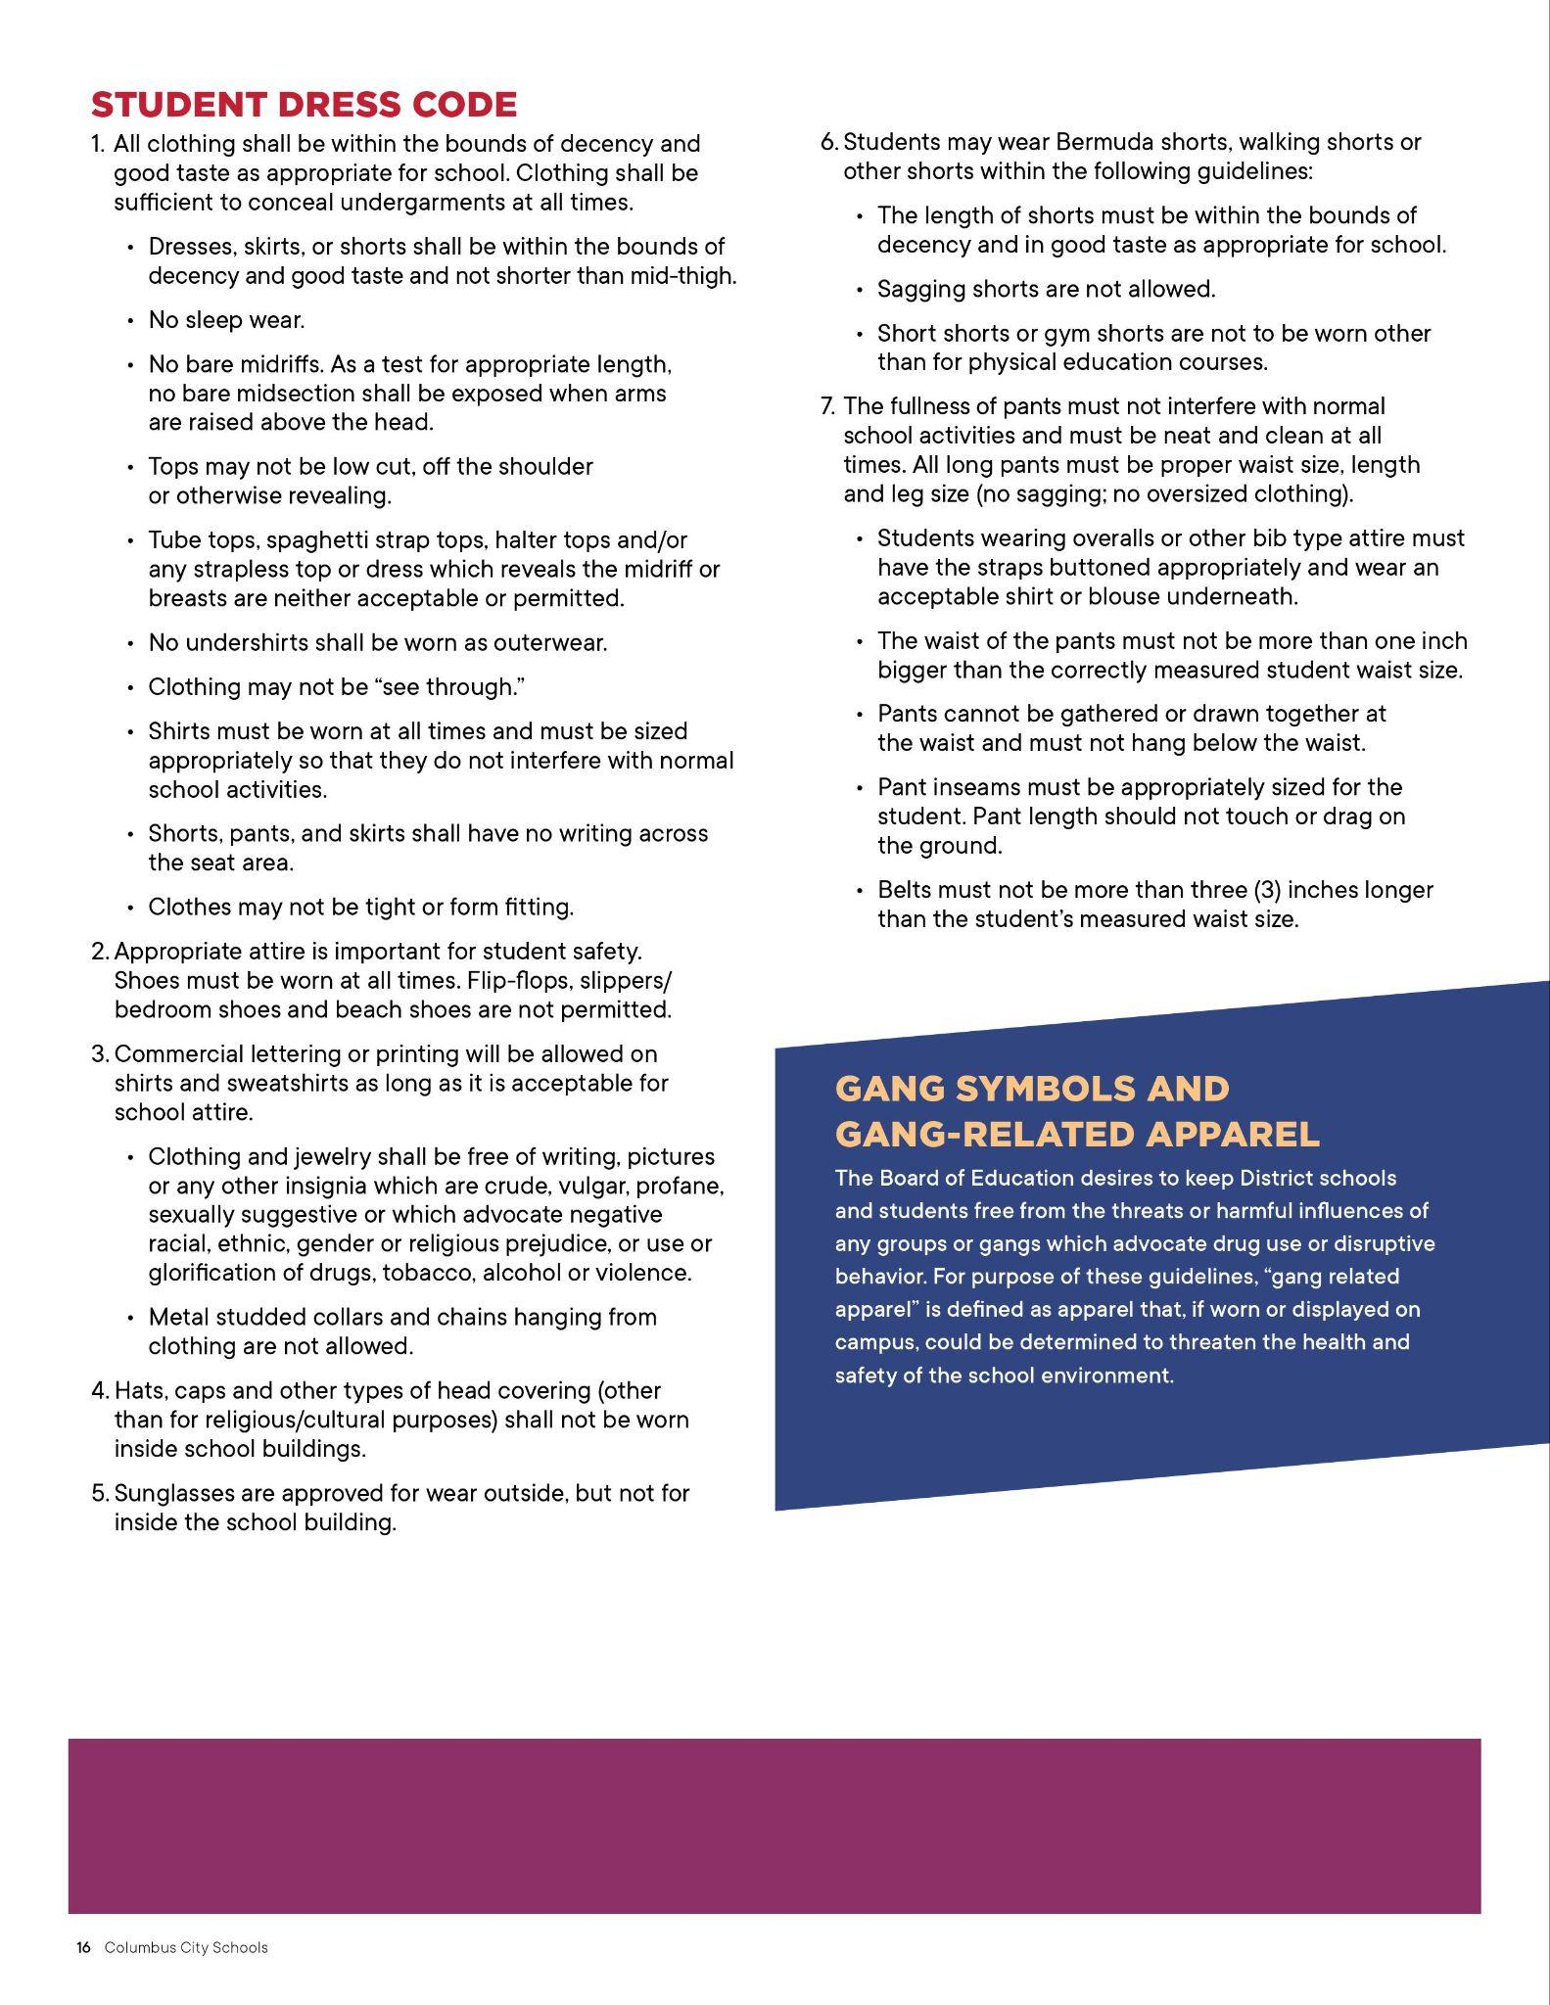

CHROMEBOOKS

Chromebooks and power cord/chargers (“PC/C”) are obtained in the Main Office only.

Chromebooks & PC/C’s, WiFi (Hot Spot) procedures:

1. ALL students must sign a Chromebook and/or WiFi Agreement in order to obtain a Chromebook and/or Hot Spot.
2. New student to the Columbus City School District. We will look at your Enrollment History prior to providing one.
3. Transfer student - we will contact your previous school to learn whether you were given a Chromebook and whether or not it was returned.
4. Repairs - ALL Chromebooks that need to be repaired or replaced MUST come to the Main Office (not the Library Conference Room). We will then notify our IT personnel to go through the Chromebook to determine if it can be repaired. We will contact you as soon as we have the Chromebook back in the Main Office from repairs. If it cannot be repaired, IT personnel will let us know to issue another Chromebook to you..
5. Power cord/chargers - PLEASE be very careful in NOT lending/losing these as we only have a **very limited supply**.
6. Transferring schools/withdrawing from school/graduating - If you are given a carry case for your Chromebook & PC/C, all of these items must be returned. (We DO track who was given a case.) If you are given a Hot Spot, you must return the box, SIM card and PC/C.

**Nurse** (N. Dana)

The School Nurse is in the building 5 days a week all day. Students must have either a written pass or e-hall pass to be seen in the clinic during instructional time. You will be sent back to class if you do not have a pass. You may stop in for small inquiries or needs between classes without a pass and one will be given to you by the nurse if the bell rings before you leave. A list of students needing to be seen during the lunch period will be given to the teachers/administration on duty. If you are not on that list you will not be allowed up to see the nurse. In the case where you feel you will need to see the nurse during that period, stop in before going down to the cafeteria and a pass will be provided. If an emergency occurs during the lunch hour staff and administration will radio up to the nurse for assistance. If the nurse is out of the building for any reason you will be directed to the proper staff within the office trained to administer care. If you have any medical conditions or medication needs, these should all be communicated to the nurse as soon as possible so the proper paperwork and supplies can be put into place to ensure your care during the school day/year.

Discipline (Kimbrough)

**Guidelines for ISS**

***ISS is assigned to students under the discretion of the administrator.***

1. Teacher will take attendance daily and inform the administration/safety & security of students present/absent via email before the end of first period.
2. Students should be assigned seats in ISS and the seating chart will change daily.
3. Students' cell phones will be locked away daily in a classroom safe provided by the school. There should be no cell phones in ISS. Cell phones will be returned at the end of the day.
4. Engage in restorative conversations/activities with students concerning their infraction. This should be done with each new student assigned.
5. Enforce student expectations daily and remain consistent. Students are expected to quietly work on their assignments in ISS.
6. Students are to take restroom breaks at times designated by the teacher but not during 5th period lunch. Students are to be escorted to the restroom and escorted back to the ISS Room.
7. ISS students will eat lunch in the cafeteria during 4th period. All students should remain under the authority of the teacher at all times. No students should be going off on their own.

1. Students are to remain in the ISS room until the end of the school day.

**Tentative Discipline Plan**

**Tardiness:**  Walnut Ridge High School has a tardy policy. Please be reminded that students who come late to class should be admitted.Students should not be turned away from the classroom. Teacher will explain the classroom tardy procedures.

1st Tardy: Conference with student

2nd Tardy: Phone call home to parent

3rd Tardy: Discipline referral - With documentation of conference and phone call home

*\*Columbus City Schools does not condone suspension for attendance related discipline*

**Discipline Levels & Summary of Strategy and Consequences**

**Level I:** – Minor offenses. Primarily initially handled by the classroom teacher.

**Level II:** Definition: Level II – Repeated Level I offenses or serious misconduct.

**Level III:** Definition: Level III – Repeated Level I or Level II offenses, illegal and/or,serious misconduct or life or health threatening offenses.

Multiple options for correcting student behavior may be selected depending on individual student needs including the age and grade level of the student, history of misbehavior, and seriousness of any specific offense.

The administration reserves the right to objectively determine consequences based on the seriousness of a particular infraction and the previous discipline record of the student who commits the offense.